Strings Supply List
If purchasing items online, use Shar, Johnson Strings, or Amazon.
(DO NOT PURCHASE INSTRUMENT ONLINE)
Items | Where To Find Item | Image
Instrument and Bow | Rent/Buy from local music store. Depending on student, the violin/viola/cello will be 1/4size – full size. The music store will help you find the correct size.
Case | Case should come with rented instrument. If purchasing instrument, cases can be bought at music store or online. Make sure case size fits violin/viola/cello size.
Rosin | Rosin can be located at a music store or online. | 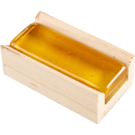
Cleaning Cloth | You can purchase a cleaning cloth or use an old t-shirt to keep in the violin case.
Folding Music Stand | Can be found online or at a music store. | 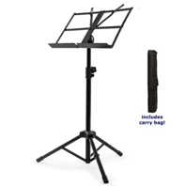
Shoulder Rest  (Violins and Viola ONLY) | Purchase Foam Shoulder Rest online or at a music store. | 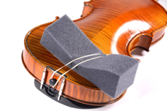
Tapes | Tapes can be put on instrument at the local music store, or by music teacher. | 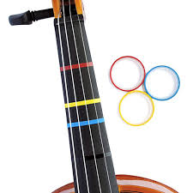
Rock Stop  (Cello and Bass ONLY) | Can be purchased online or at a music store. | 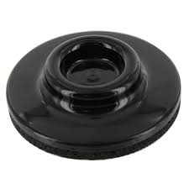
Notebook and Pencil | Empty notebook and pencil for every lesson!
Music  (Will Be Assigned After School Assessment) | Music books can be purchased online.

