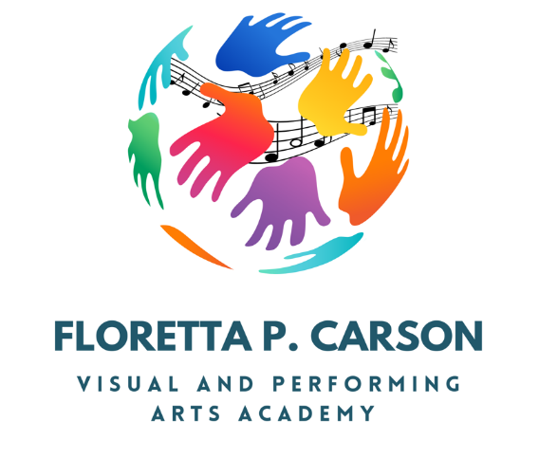
2024-2025
Registration Fees
Payment Plan
Welcome to Floretta P. Carson Visual and Performing Arts Academy’s new academic year. Registration fees for your student this year are $250 (per student). These fees help us offset the cost of technology and allow us to provide a world-class individualized learning experience for your child.
To help reduce the financial burden, we are offering payment plans for parents who need the flexibility to pay over the course of 5 payments. If you did not make a payment during registration, you can submit payments according to the following payment plan schedule.
The remaining payments will be paid according to the schedule listed below:
- $50 due on or before October 31st
- $50 due on or before November 30th
- $50 due on or before December 31st
- $50 due on or before January 31st
- $50 due on or before February 31st
TOTAL Payments: $250
Please note that students will not be able to participate in any school related social events (i.e. fall dance, winter formal, etc.) unless registration fees are being paid in accordance with your payment plan.
Payments can be paid in the front office during regular school hours. Please retain your receipts for each payment made for your records.

SIGNATURES
I have received a copy of the Payment Plan Agreement for my student’s registration fees. The signatures below indicate agreement by all parties (Parent, and Floretta P Carson Academy Staff) to adhere to the terms listed.

Parent: ___________________________ _________________________ Date: ____/____/_____
(print name) (signature)

Academy Faculty/Staff: (check position) Administrator Teacher
___________________________ _________________________ Date: ____/____/_____
(print name) (signature)

